|  |  |
| --- | --- |
| **Name:- Aryan Dilipbhai Langhanoja** | **Roll Number:- 92200133030** |
| **Subject Name and Code:-** Foundation Skills On Sensor Interfacing (01CT1103) | **Date of Experiment:- 15-12-2022** |

|  |  |
| --- | --- |
| Task:- |  |

* Interface Servo with arduino uno development board and learn how to use servo motors for various applications.

|  |  |
| --- | --- |
| Components: |  |

* Arduino Uno R3
* Servo Motor
* Jumper Wires (Male To Male)
* Laptop Or PC

|  |  |
| --- | --- |
| About the Project:- |  |

* In thisproject, we are going to interface Servo Motor with Arduino. For that we will connect the VCC pin to +5V and Ground pin into GND. And Signal pin to any of the Digital Pin Of the Arduino.

|  |  |
| --- | --- |
| Schematic:- |  |

|  |  |  |
| --- | --- | --- |
| Output:- (you circuit implementation |  |  |

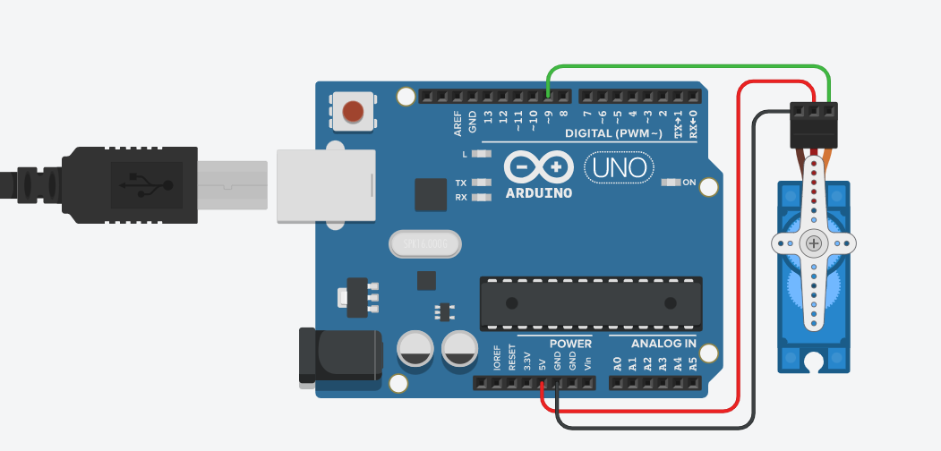

|  |  |
| --- | --- |
| Code:- |  |

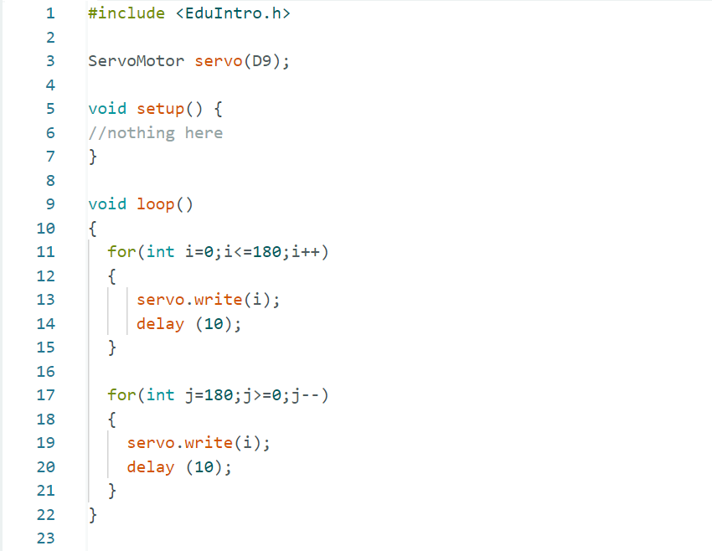

|  |  |
| --- | --- |
| Conclusion:- |  |

* In This Experiment, We Learnt That How To Interface Servo motor with The Arduino.